1. Introduction

1. Introduction
Unified Payments Interface (UPI) has revolutionized digital transactions in India by enabling fast, secure, and seamless money transfers. As UPI usage continues to grow, ensuring that a UPI ID (Virtual Payment Address) is valid and correctly formatted has become increasingly important for businesses, developers, and financial platforms.
The UPI Checker project is designed to verify the authenticity and structure of UPI IDs before they are used in a transaction. This tool helps reduce payment failures, prevents errors caused by invalid VPAs, and enhances overall user trust in digital payment systems. By integrating validation logic, pattern matching, and (optional) real-time verification through payment APIs, the UPI Checker provides a reliable way to confirm whether a UPI ID exists and is ready to receive payments.

1.2 Existing System
In the current scenario, many users and businesses rely on manual checking to verify a UPI ID. This involves entering the UPI ID in a payment app (like Google Pay, PhonePe, or Paytm) and attempting a small transfer to see if the receiver details appear correctly.

1.3 Scope of System
The scope of the system defines the boundaries, capabilities, and functionalities that the UPI Checker project aims to deliver. This system is designed to verify UPI IDs efficiently and ensure reliable validation for users, businesses, and digital platforms. The UPI_CHECKER System focuses on validating UPI IDs, identifying incorrect formats, logging verification attempts, and providing a simple interface for users and admins.

1.4 Operating Environment-Hardware and Software
Hardware: Basic computer system
Hardware Requirements
Component | Specification
Processor | Intel i3 or higher
RAM | Minimum 4 GB
Storage | At least 2 GB free space
Display | 1024 × 768 resolution
Internet | Required for UPI API

Software Requirements
Component | Specification
Operating System | Windows 10/11
Server Package | XAMPP (Apache, MySQL, PHP)
PHP Version | PHP 7.4 or above
Database | MySQL / MariaDB
Tools | phpMyAdmin, Browser, Code Editor (VS Code/Notepad++)

1.5 Project Modules
1. User Interface Module
2. UPI Validation Module
3. Database Module

2. Proposed System

2.1 Proposed System
A secure, reliable, and automated system for validating UPI IDs with logging and admin monitoring. The Proposed System automates UPI validation using predefined rules, database lookups, and real‑time response generation to reduce errors and increase efficiency.

2.2 Feasibility Study
- Technical feasibility:
1)The system uses common and widely supported technologies such as HTML, CSS, JS, PHP, and MySQL.
2)All required software like XAMPP/WAMP is free and easy to install.
3)The project runs on normal hardware and does not require high-end configuration.
- Economic feasibility:
1)Development cost is low as all tools and frameworks used are open-source.
2)No need to purchase additional hardware or paid software.
3) Maintenance cost is minimal due to simple design and small database.

- Operational feasibility:
1)The system interface is simple, clean, and user-friendly.
2) Easy for both technical and non-technical users to operate.
3) Process flow is straightforward, requires very little training.

2.3 Objective of Proposed System
• Validate UPI IDs automatically
• Reduce manual errors
• Maintain validation logs
• Provide a user-friendly interface

2.4 Users of System
• Normal Users
• Admin Users

3. Analysis and Design

3.1 Entity Relationship Diagram
ER diagram represents relationships between user, UPI records, and logs. This section includes diagrams for understanding workflow and structure.
Entities: User, upi-checker, enter upi, check upi, CHECKING, Valid or InValid, Report
Relationships:
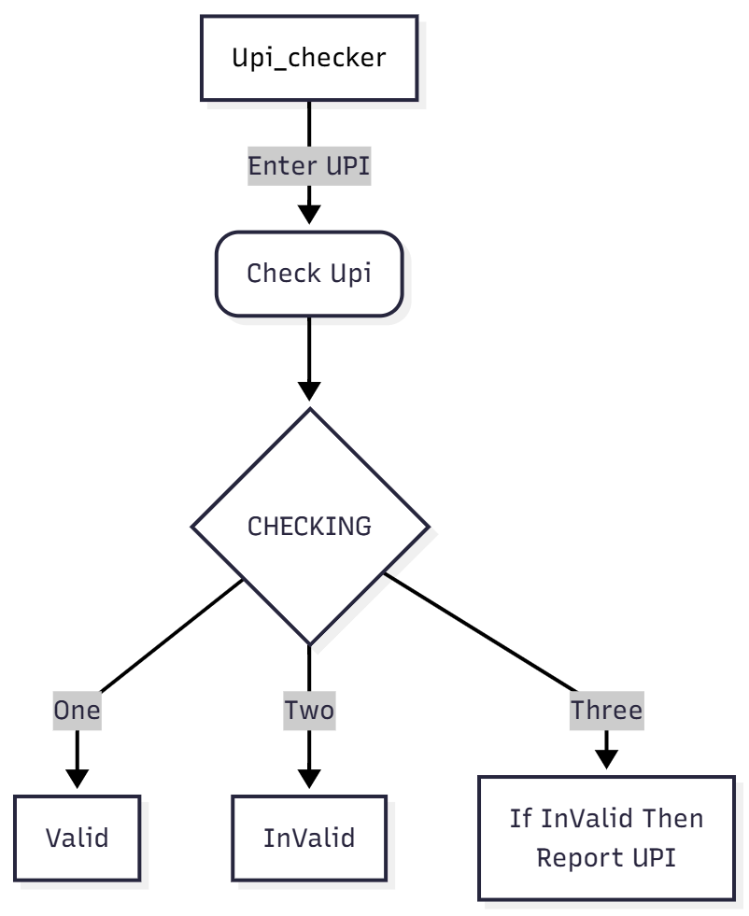

3.2 Class Diagram
Class diagram contains classes such as User, and His/Her Actions Performed
Classes:
- User: enter upi, check upi, valid, invalid

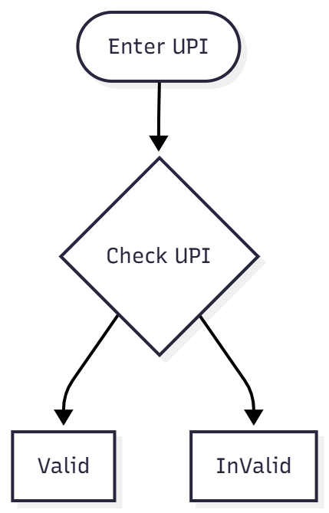

3.3 Use Case Diagram
Shows how users interact with system features like Validate UPI and View Logs.
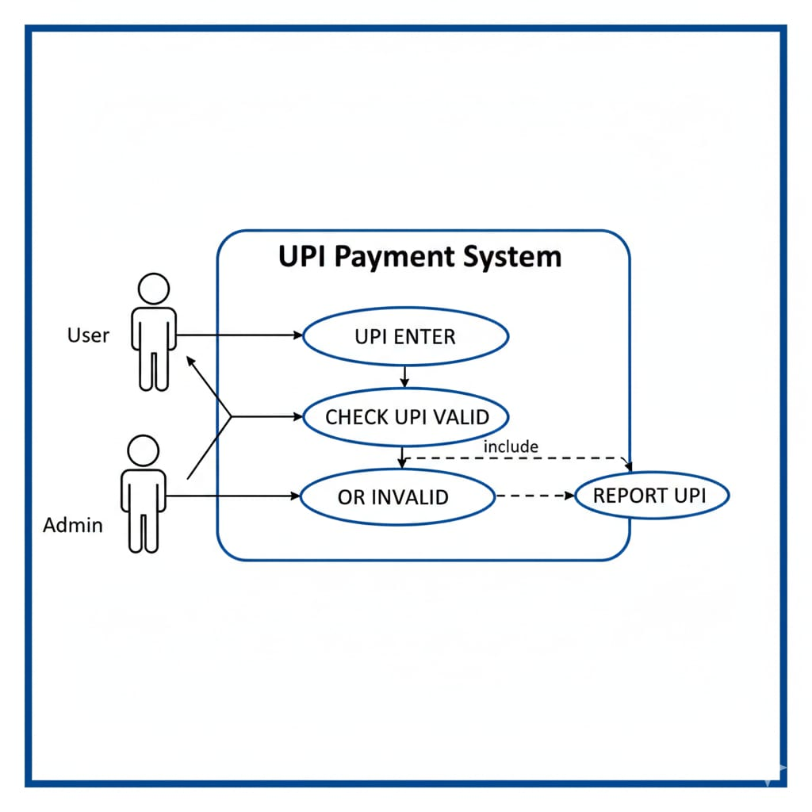

3.4 Activity Diagram
Illustrates the sequence of validation steps.
1.User
2. Enter UPI
3.Check Valid or InValid

3.5 Dataflow Diagram
Depicts flow of data through modules.
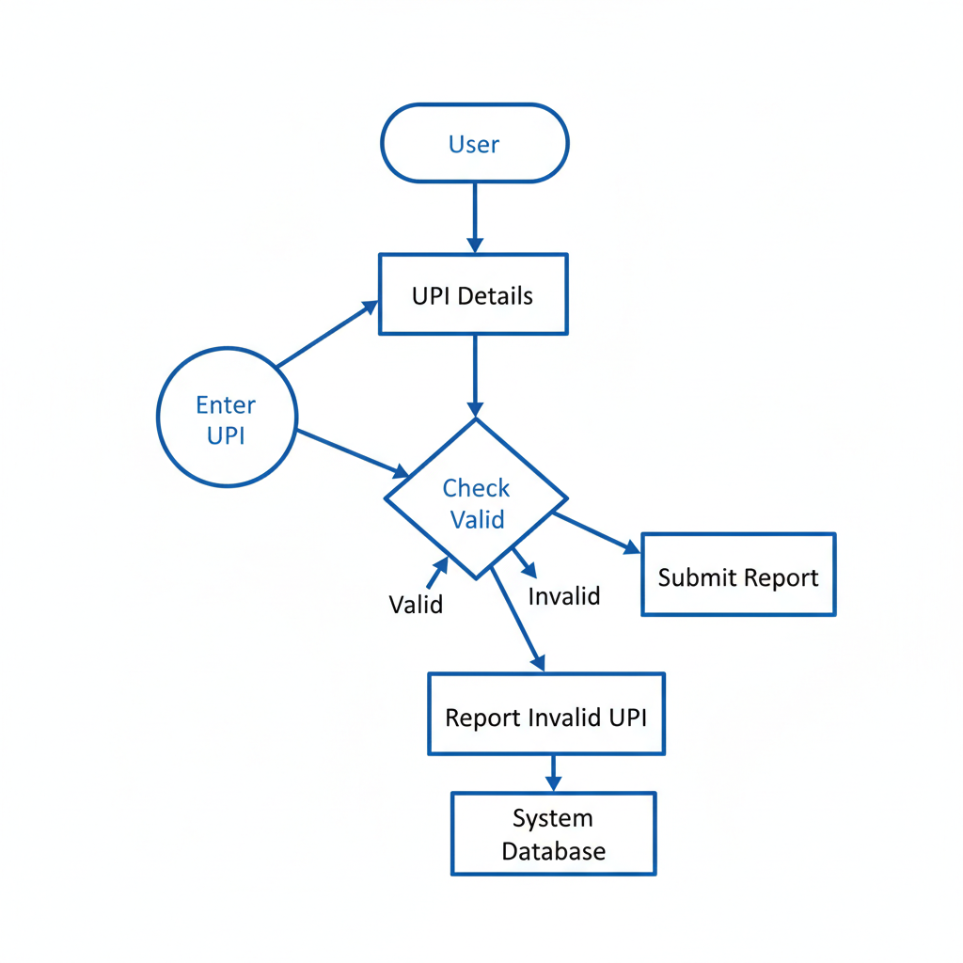

3.6 Deployment Diagram
Shows system installation on server and client side.
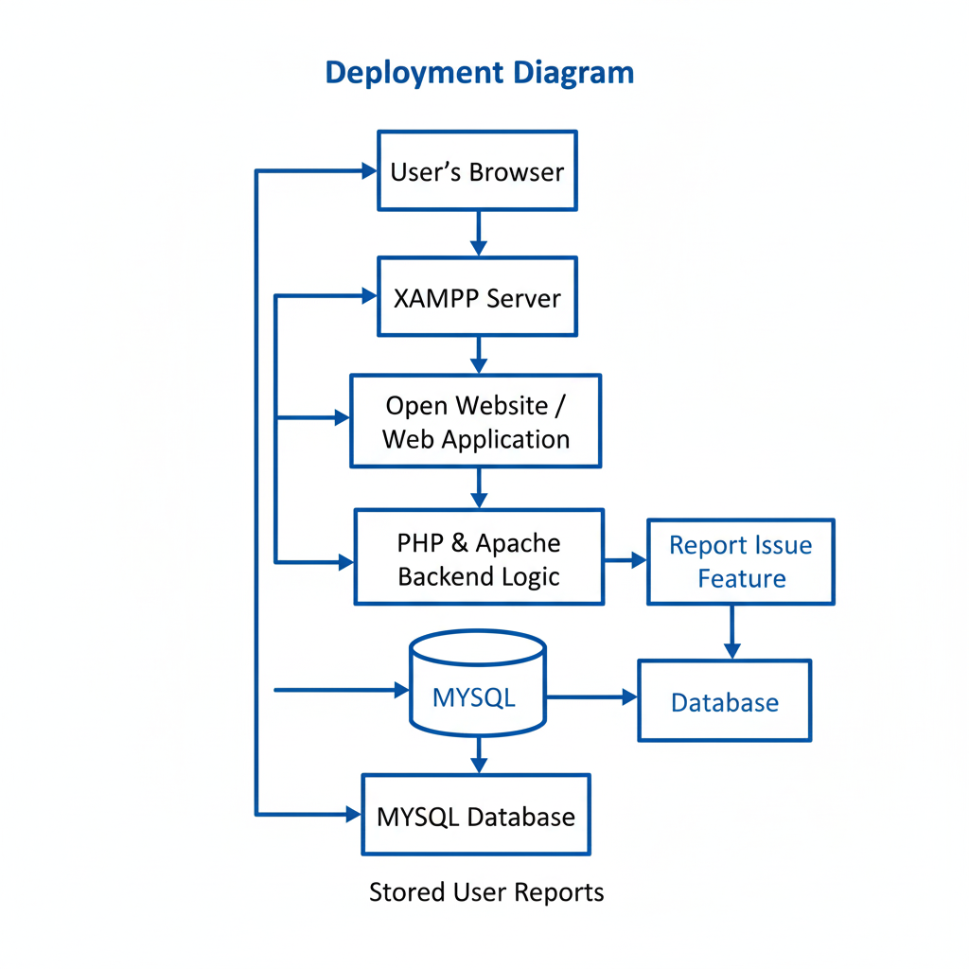

3.7 Module Hierarchy Diagram
Shows top-down structure of UPI_CHECKER modules.
│ ├── Open Website
│ ├── Enter UPI
│ ├── Check UPI
│ └── Valid/InValid
├── Report if InValid
│ ├── Admin

3.8 Table Structure
• User Table
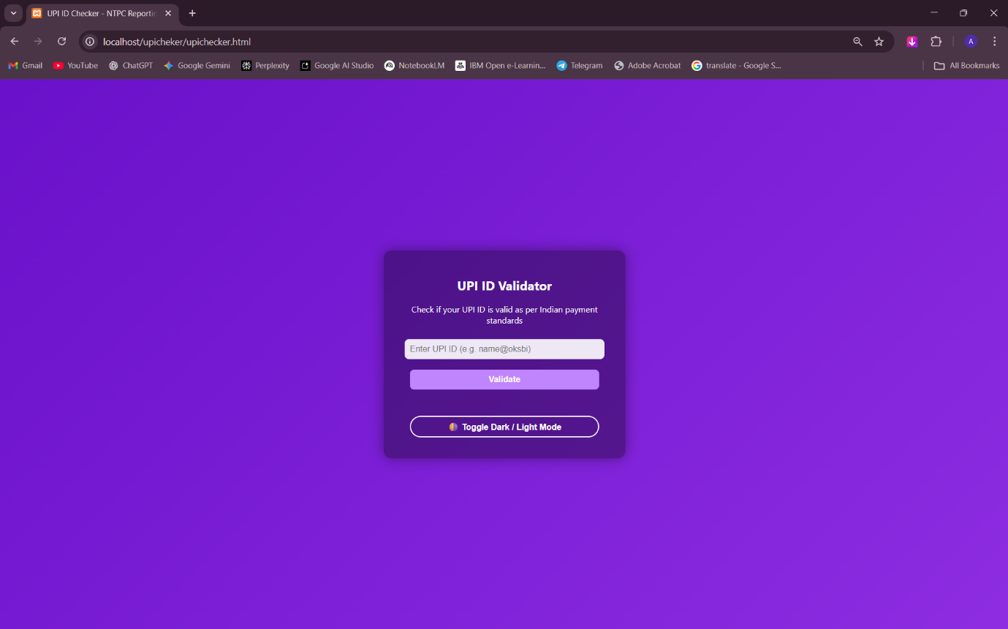
• UPI_Validation_Log Table
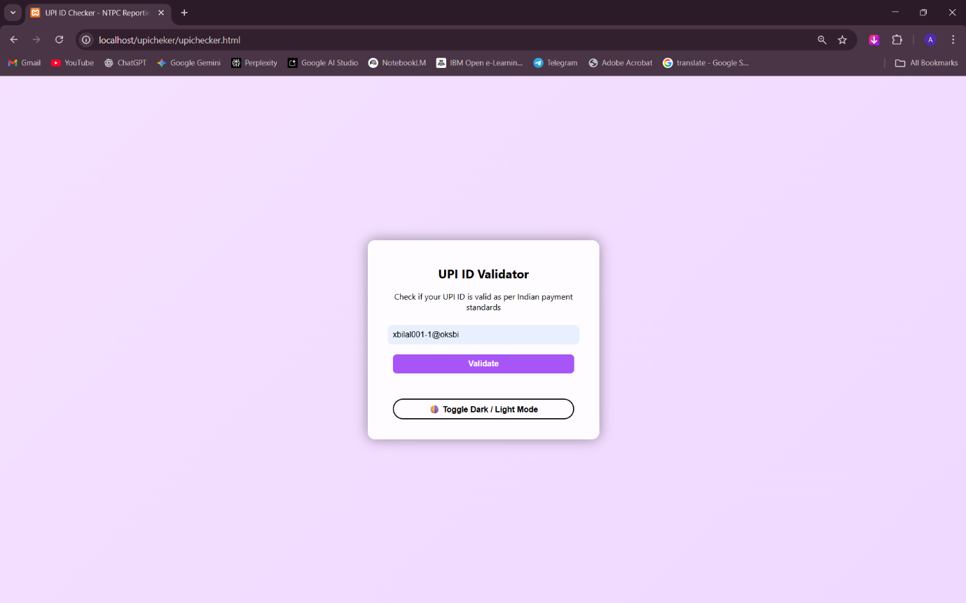

• Admin Table
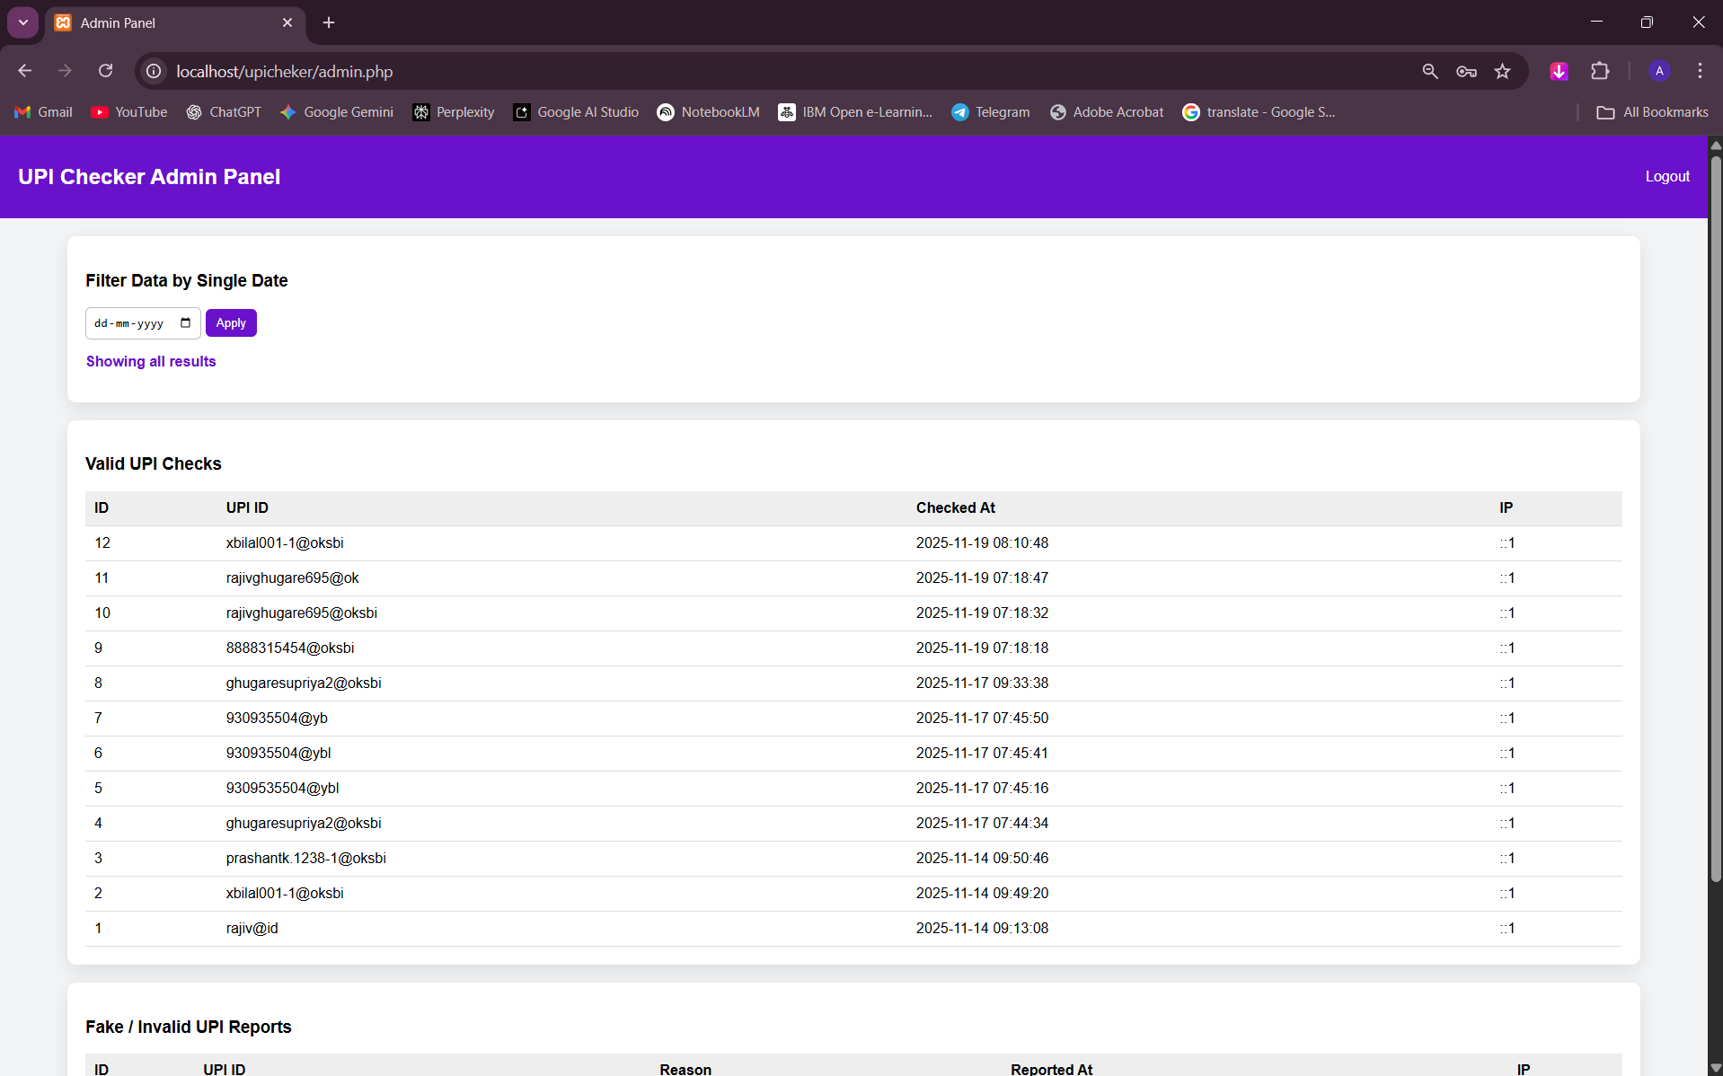

3.9 Sample Input Output Screens

Screens such as Login/As its has Theam Wallpaper:
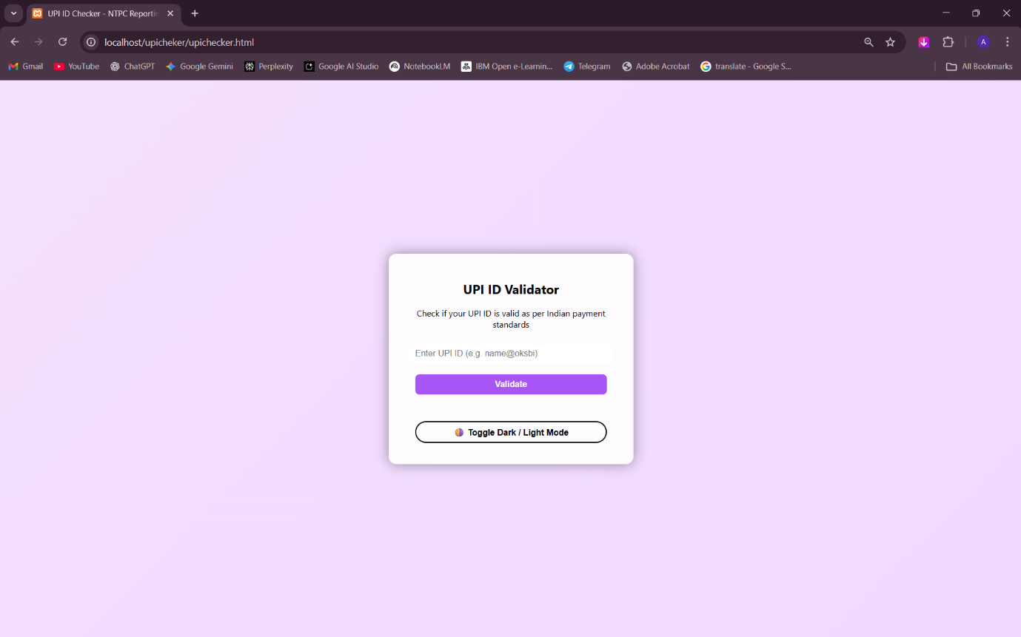

UPI Validation:
Check is Its Valid:
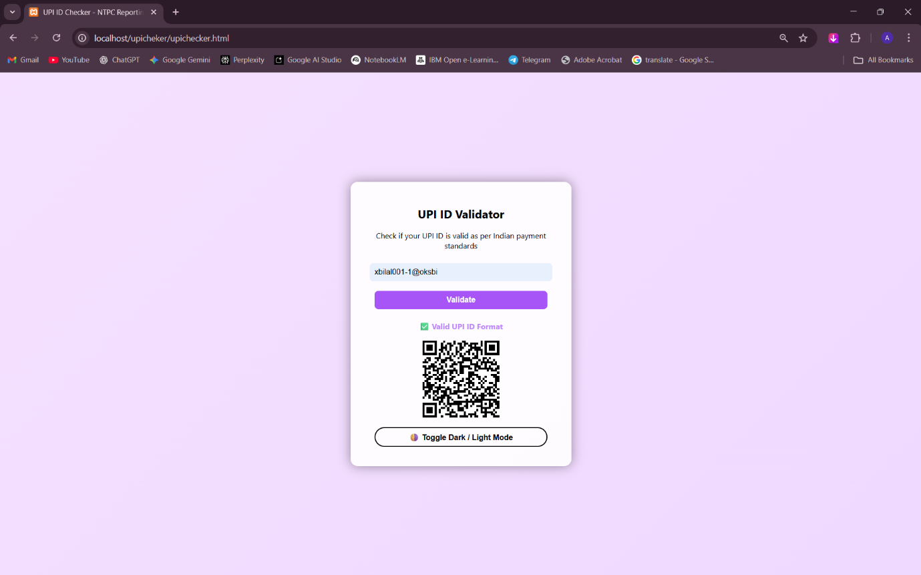

Checks if Its Invalid:
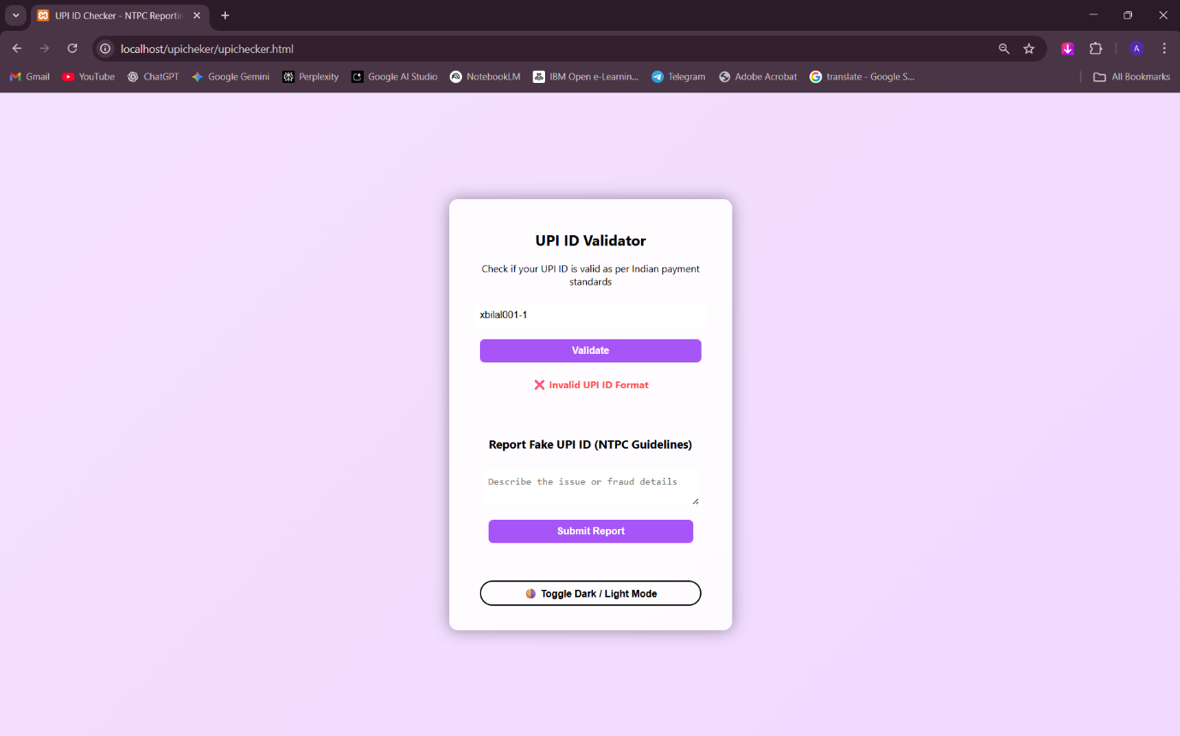
Reported Page:
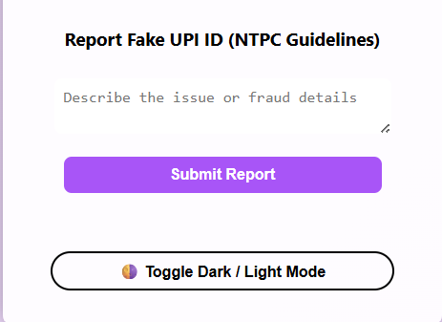

Once’s Its Reported/Message Appears:
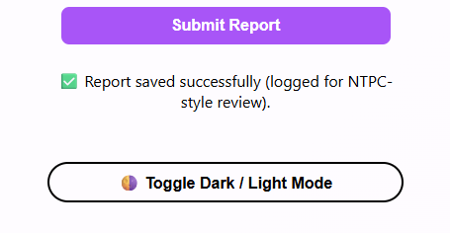
Admin Dashboard:
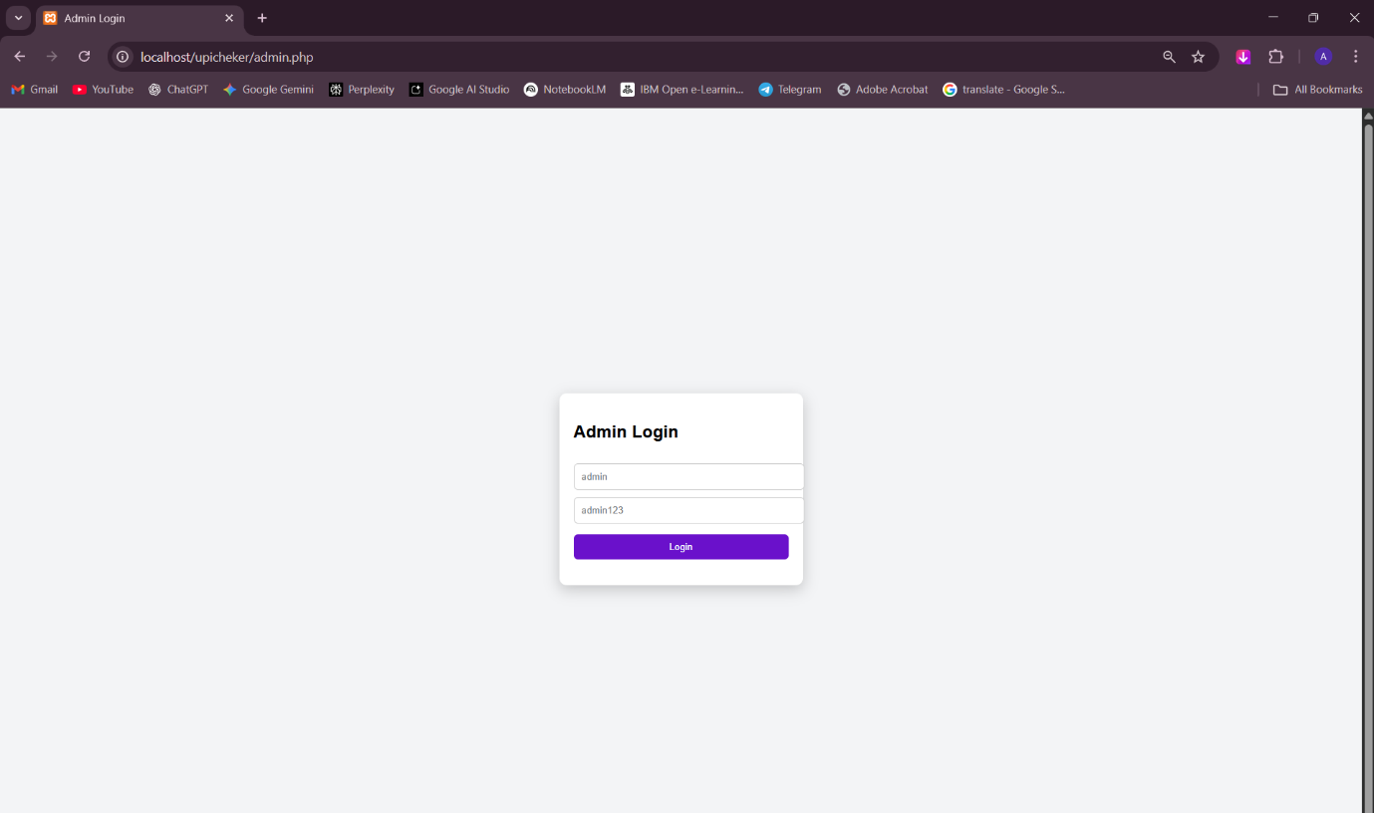

DataBase:
Reported UPI:
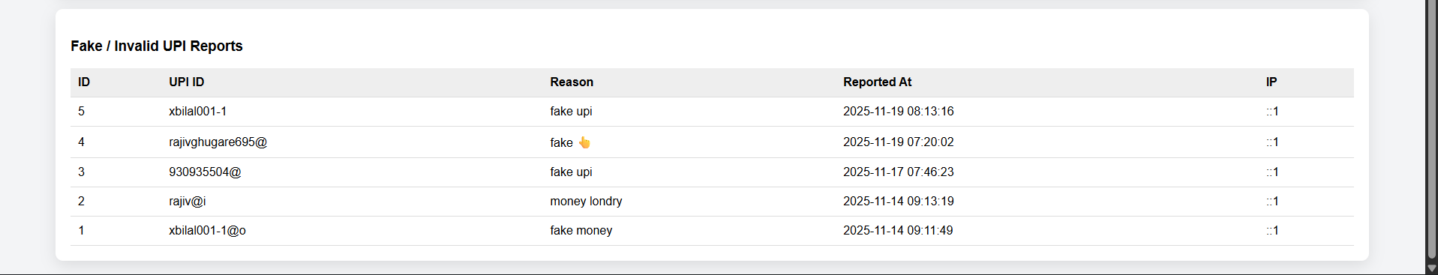

4. Limitations of Proposed System

4. Limitations of Proposed System

1. No Guaranteed Real-Time Verification
The system may not always confirm the actual existence of a UPI ID if real banking/UPI APIs are unavailable.
It can validate format and handle, but full verification may be limited.

2. Dependency on Third-Party APIs (If Used)
If the system integrates with external APIs or PSPs, its accuracy depends on their availability, response speed, and reliability.

3. Limited Access to UPI Network
The system cannot access confidential UPI infrastructure directly, which restricts verification to safe and publicly allowed methods only.

5. Proposed Enhancement

5. Proposed Enhancement
• API integration with UPI service providers
• Real-time verification with banks
• Mobile app version
• Support for Bulk UPI ID Verification
• Enhanced Error Detection

6. Conclusion

6. Conclusion
The UPI_CHECKER project provides fast and efficient UPI validation improving security and reliability. system provides an effective and reliable solution for validating UPI IDs (Virtual Payment Addresses) before they are used in any digital transaction. By automating the verification process, the system reduces errors, minimizes transaction failures, and enhances user confidence in digital payment platforms.
Through features such as format validation, handle verification, and real-time feedback, the project ensures that users can quickly identify invalid or inactive UPI IDs without initiating a financial transaction.

7. Bibliography

7. Bibliography
1. Korth, H. F., Silberschatz, A., &Sudarshan, S. (2011). Database System Concepts. 6th Edition. McGraw-Hill Education.
2. Sommerville, I. (2015). Software Engineering. 10th Edition. Pearson Education.
3. Pressman, R. S. (2014). Software Engineering: A Practitioner’s Approach. 8th Edition. McGraw-Hill Education.
4. Welling, L., & Thomson, L. (2017). PHP and MySQL Web Development. 5th Edition. Addison-Wesley.
5. Singh, A. K., & Gupta, R. (2018). Web Application Development and Database Management. International Journal of Computer Applications, 182(10), 15–22.
6. TutorialsPoint. (n.d.). MySQL Tutorial. Retrieved from https://www.tutorialspoint.com/mysql/
7. GeeksforGeeks. (n.d.). PHP and Database Connectivity. Retrieved from https://www.geeksforgeeks.org/php/
this is we called Bibliography so please make that change and in hardware and software requirement

8. User Manual

8. User Manual
Steps:
1. Enter UPI ID
2. Click Validate
3. View Result
4. Admins can view logs

